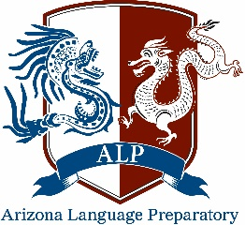
Arizona Language Preparatory Board of Directors
School Board Meeting
11/7/16
Agenda
- Notice of Meeting
  - Pursuant to Arizona Revised Statutes (A.R.S.) § 38-431.02, notice is hereby given to the members of the Arizona Language Preparatory Board of Directors and to the general public that the Board will hold a public meeting, open to the public as specified below. The Board reserves the right to change the order of the items on the agenda, with the exception of public hearings set for a specific time. One or more members of the Board may participate in the meeting by telephonic communications.
  - Pursuant to A.R.S. § 38-431.03(A)(3) the Board may vote to go into Executive Session, which will not be open to the public, for legal advice concerning any item on the agenda.
  - Location and time of meeting: Arizona Language Preparatory, 4645 E Marilyn Rd, Phoenix AZ 85032. 4:30p.
- Roll Call
- Call to the public
  - This is the time for the public to comment. Members of the Board may not discuss items that are not specifically identified on the agenda. Therefore, pursuant to A.R.S. § 38-431.01(H), action taken as a result of public comment will be limited to directing staff to study the matter, responding to any criticism, or scheduling the matter for further consideration and decision at a later date.
- Action items
  - Approve previous minutes
- Discussion items
  - Staffing update
  - Curriculum update
  - Behavior plan
  - Classroom cleaning
  - Teacher celebrations & concerns
  - Teacher meeting effectiveness
- Announcement of future meeting date
  - The Board of Directors meeting 12/19/16 @ 4:30p
- Adjournment

